Paddles Development Swimming Gala Entry Form
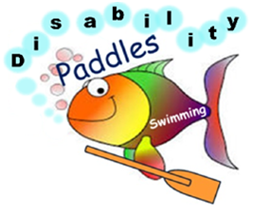
Cheadle Saturday 25th November 2017

Name .........................................................................................................

Address ....................................................................................................

....................................................................................................................

Post code............................................ DOB .............................................
E-Mail Address..........................................................................................
List of Events
Please enter a time for your events if known.
Event | Time
Non-swimmer splash & Dash | No time needed
10m Front | No time needed
10m Back | No time needed
25m Freestyle
50m Freestyle
25m Breaststroke
50m Breaststroke
25m Backstroke
50m Backstroke
25m Butterfly
50m Butterfly
100m Individual Medley

Epileptic Yes / No (please circle)
Please return the entry form/photo consent form by Saturday 18th November 2017 to:
Anna Lavan 4 Oak Street, Cheadle Staffordshire ST101NX
Paddles
Photographic / Film Consent Form

Name of participant................................................................................................. or

(Parent or guardian)................................................................................................

Date of Birth of participant.....................................................................................

Address (inc postcode)..........................................................................................

..................................................................................................................................

Contact Telephone Number..................................................................................

E-mail Address.......................................................................................................

Paddles would like to *take your photograph / *make a video of you for promotional and documentary purposes. These images may appear in our printed publications, on video, on our website, or all three.
To comply with Data Protection Act 1998, your permission is required before we take any photographs or recordings of you. Please answer the questions overleaf, then sign and date the form where shown. (Please circle answer)

- I agree the use of my image in your own printed publications produced by Paddles Swim School for promotional and documentary purposes?
Yes No

- I agree the use of my image on your web-site?
Yes No

- I agree the recording of my image on our promotional videos?
Yes No

- I agree the use of my image in printed publications produced by others for promotional and documentary purposes?
Yes No

Signature...........................................................................

Date..................................................................................

In accordance with the Data Protection Act 1989, the information you give us will be held on our database for the purpose of supplying you with information. Please tick if you agree ( )

